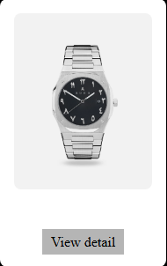

**Product Name: Luxury Stainless Steel Wristwatch**

**Description:**

**This elegant timepiece combines timeless design with modern functionality. Crafted with a durable stainless-steel strap and a sleek black dial, it features numerals in a unique script that adds a touch of exclusivity. Ideal for both casual and formal wear.**

**Specifications:**

* **Dial Color: Black**
* **Strap Material: Stainless Steel**
* **Movement Type: Quartz**
* **Display Type: Analog**
* **Water Resistance: Up to 50 meters**
* **Case Diameter: 42 mm**

**Price:**

**$259.00 USD**